LungGuard AI
Software Design Description Document
Version: 1.0
Zohaib hassan
Session: 2022-2026
F22BDOCS1E02029
Islamia University Bahawalpur
December 24, 2025

Revision History
Date | Description | Author | Comments
24/12/2025 | Initial Draft Created | ZOHAIB HASSAN | First Version

Document Approval
The following Software Requirements Specification has been accepted and approved by the following:
Signature | Printed Name | Title | Date
 | Dr. Imran Sarwar Bajwa | Supervisor, CSIT 21306 | 24/12/2025

Table of Contents
1. INTRODUCTION 5
1.1 Purpose 5
1.2 Scope 5
1.3 Overview 6
1.4 Definitions and Acronyms 6
2 SYSTEM OVERVIEW 7
3 SYSTEM ARCHITECTURE 7
3.1 Architectural Design 7
3.2 Decomposition Description 8
3.3 Design Rationale 8
3.3.1 Technology Selection Rationale: 8
3.3.2 Architectural Pattern Rationale: 9
3.3.3 Security and Compliance Considerations: 10
4 DATA DESIGN 10
4.1 Data Description 10
4.2 Data Dictionary 10
5 COMPONENT DESIGN 14
6 HUMAN INTERFACE DESIGN 14
6.1 Overview of User Interface 14
6.2 Screen Images 14
6.3 Screen Objects and Actions 14
7 REQUIREMENTS MATRIX 14
8 APPENDICES 16
8.1 Unit Testing: 16
8.2 Test Categories: 16
8.3 Integration Testing: 16
8.3.1 End-to-End Workflow Testing: 16
8.3.2 Database Integration Tests: 16
8.3.3 File System Integration: 18
8.3.4 API Integration Testing: 18
8.4 Performance Testing: 18
8.4.1 Load Testing: 18
8.4.2 Stress Testing: 18
8.4.3 CT Scan Processing Benchmarks: 18
8.5 Medical Validation Testing: 18
8.5.1 AI Model Accuracy Validation: 18
8.5.2 Clinical Workflow Usability Testing: 18
8.5.3 Report Accuracy Testing: 19
8.6 Compliance Testing: 19
8.6.1 HIPAA Compliance Testing: 19
8.6.2 Accessibility Testing: 19
8.6.3 Browser Compatibility Testing: 19
9 .Reference Material 19

INTRODUCTION
PulseLungs is an advanced diagnostic support system designed to assist radiologists in the early and accurate detection of lung cancer from CT scan images. It addresses a critical global health challenge by leveraging state-of-the-art artificial intelligence, specifically Convolutional Neural Networks (CNNs), to automate the analysis of medical imagery. The system is developed as a secure, web-based platform that integrates seamlessly into a clinical workflow, providing rapid and reliable second-opinion analysis. By classifying scans into categories such as Healthy, Benign, or Malignant and further identifying specific cancer types, PulseLungs serves as a powerful augmentation tool. It is built to enhance the diagnostic process, reduce interpretation time, and support clinical decision-making, all while ensuring the radiologist remains the final authority in the diagnostic chain. This document outlines the comprehensive software requirements for developing, deploying, and maintaining this innovative medical support system

Purpose
The primary purpose of PulseLungs is to develop a sophisticated software tool that empowers radiologists to improve the early detection and classification of lung cancer. It aims to mitigate the high mortality rate associated with late-stage lung cancer diagnosis by providing an AI-powered, instantaneous analysis of CT scans. The system is engineered to deliver automated predictions regarding cancer presence (Healthy, Benign, Malignant) and, when applicable, its specific type, accompanied by a confidence score for each result. This functionality is intended to boost diagnostic accuracy, streamline the radiologist's workflow, and facilitate earlier medical intervention for patients. Crucially, PulseLungs is designed as a supportive aid that complements professional medical expertise, not as an autonomous diagnostic entity. Its ultimate goal is to contribute to better patient outcomes through timely and precise analytical support, reinforcing the radiologist's critical role in the healthcare ecosystem.

Scope
PulseLungs is a web-based diagnostic support system designed to assist radiologists in early detection and classification of lung cancer from CT scan images. The system provides secure radiologist authentication, CT scan upload and validation, AI-powered cancer detection using CNN models trained on the IQ-OTH/NCCD dataset, instant diagnosis reporting with confidence scores, and comprehensive report history management. The platform is built using Django framework with TensorFlow/PyTorch for AI integration and follows medical software standards for data security and clinical usability.
The system will provide:
- Secure radiologist authentication and session management
- CT scan upload in DICOM/JPEG/PNG formats with validation
- AI-based lung cancer detection (Healthy/Benign/Malignant classification)
- Cancer type identification for malignant cases
- Confidence-based diagnosis reporting
- Report history management with search and filter capabilities
The system will NOT provide:
1. Automated treatment recommendations
2. Direct patient management features
3. Advanced 3D reconstruction of CT scans
4. Mobile application interface
5. Real-time imaging capabilities

Overview
PulseLungs is a secure, web-based diagnostic platform built on the Django framework. It integrates a specialized Convolutional Neural Network (CNN) trained on the IQ-OTH/NCCD lung cancer dataset. The system provides radiologists with an AI-powered tool to analyze CT scans for early signs of lung cancer. Its core function is to classify scans as Healthy, Benign, or Malignant and identify specific cancer types. Each analysis is delivered with a confidence score to aid radiologist interpretation. The platform features secure authentication, a streamlined interface for uploading scans, and instant generation of diagnostic reports. All reports and patient cases are maintained in a searchable history for tracking and review. Designed for clinical environments, it enhances diagnostic workflows while ensuring data security and upholding the radiologist's role in the final diagnosis.

Definitions and Acronyms
- SDD: Software Design Document
- CNN: Convolutional Neural Network
- CT: Computed Tomography
- DICOM: Digital Imaging and Communications in Medicine
- EHR: Electronic Health Record
- API: Application Programming Interface
- MVP: Minimum Viable Product
- ORM: Object-Relational Mapping
- IQ-OTH/NCCD: Iraqi Ministry of Health and Environment-National Center for Cancer Diseases
- HIPAA: Health Insurance Portability and Accountability Act
- GDPR: General Data Protection Regulation
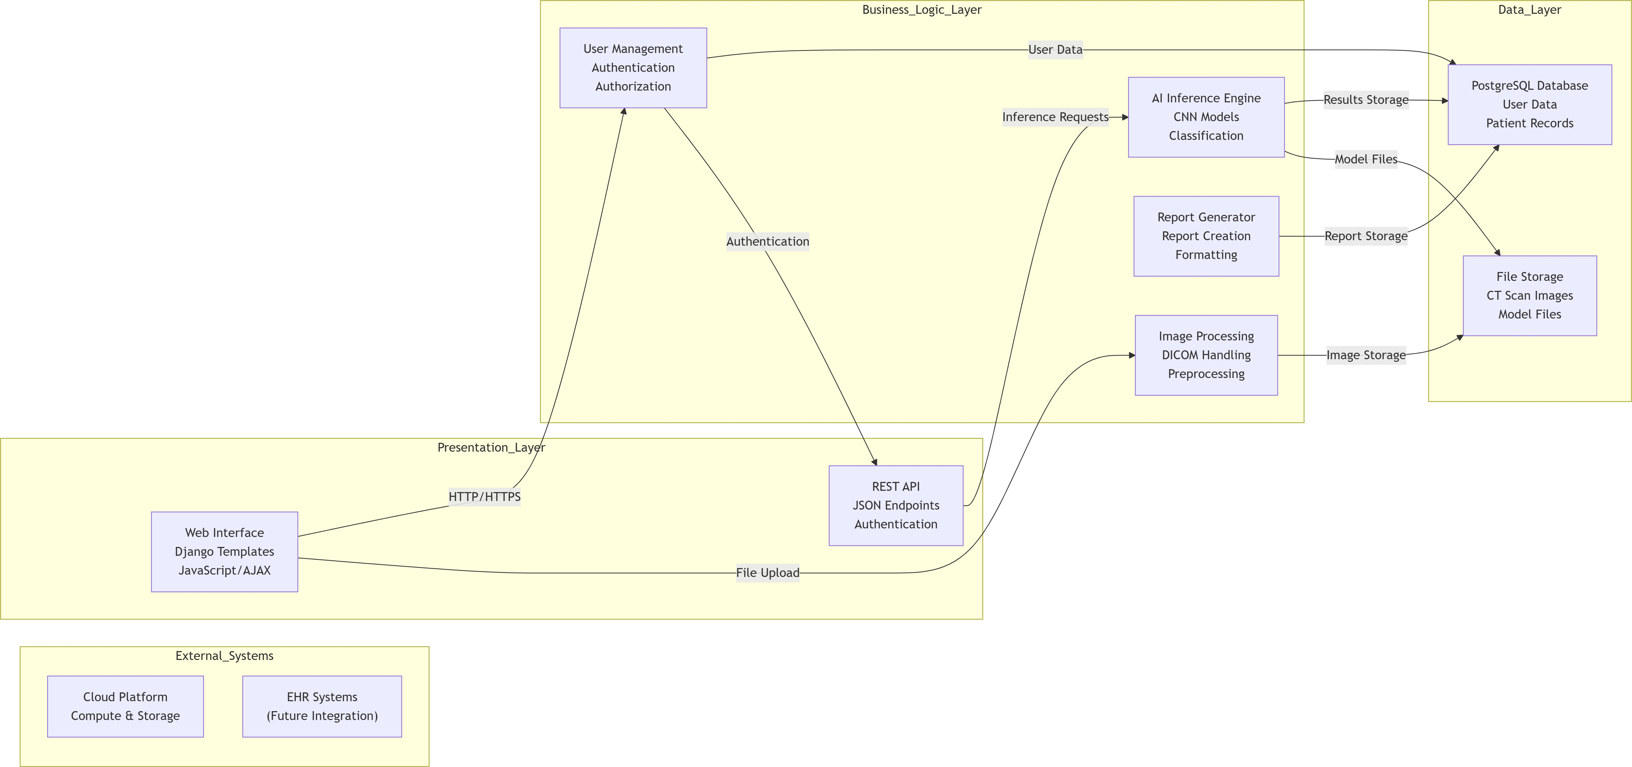
Figure 1: Architectural Design

SYSTEM OVERVIEW
PulseLungs is designed as a three-tier web application using Django framework with integrated CNN models for medical image analysis. The system follows Model-View-Controller (MVC) architecture with clear separation between presentation layer (Django templates and JavaScript), business logic layer (Django views and AI services), and data layer (PostgreSQL database and file storage). The platform is developed to operate as a diagnostic support tool in clinical environments, providing radiologists with AI-powered analysis while ensuring data security, regulatory compliance, and seamless integration with existing healthcare workflows. The technology stack includes Python 3.8+ with Django 4.x for web development, TensorFlow/PyTorch for CNN implementation, PostgreSQL for production database, and cloud deployment for scalability. The system employs a modular design with components for user management, image processing, AI inference, and report generation, each developed as independent modules that can be tested and maintained separately.

SYSTEM ARCHITECTURE

Architectural Design
The system employs a layered architecture with three main tiers: Presentation Layer, Business Logic Layer, and Data Layer, following the Model-View-Controller (MVC) pattern. This separation ensures modularity, testability, and maintainability while supporting the complex requirements of medical image analysis and diagnostic reporting.

Decomposition Description
The system is decomposed into five main modules following object-oriented design principles to enable parallel development and independent testing:
- Authentication & User Management Module: Handles radiologist registration, login, session management, and role-based access control with secure password hashing and audit logging.
- Image Management & Processing Module: Manages CT scan uploads in DI- COM/JPEG/PNG formats, validates file integrity, and performs preprocessing (normalization, contrast enhancement), and stores images securely.
- AI Processing & Inference Module: Contains CNN models for cancer detection and classification, inference engine for real-time analysis, confidence scoring, and model version management.
- Report Generation & Management Module: Generates comprehensive diagnostic reports, manages report history, provides search/filter capabilities, and handles report validation by radiologists.
- Administration & Monitoring Module: Provides system configuration, user management, performance monitoring, audit trails, and system health checks.

Design Rationale
The architectural decisions were driven by clinical requirements, technical constraints, and academic project scope:

Technology Selection Rationale:
- Django Framework: Selected for built-in security features, ORM capabilities, admin interface, and rapid development suitable for medical applications requiring regulatory compliance.
- PostgreSQL Database: Chosen over SQLite for production due to better performance with medical imaging metadata, ACID compliance, and advanced data types supporting JSON for model metrics.
- TensorFlow/PyTorch: Used for CNN implementation due to extensive medical imaging libraries, pre-trained models for transfer learning, and research community support.
- REST API Design: Enables future integration with EHR systems while maintaining separation between frontend and backend for maintainability.

Architectural Pattern Rationale:
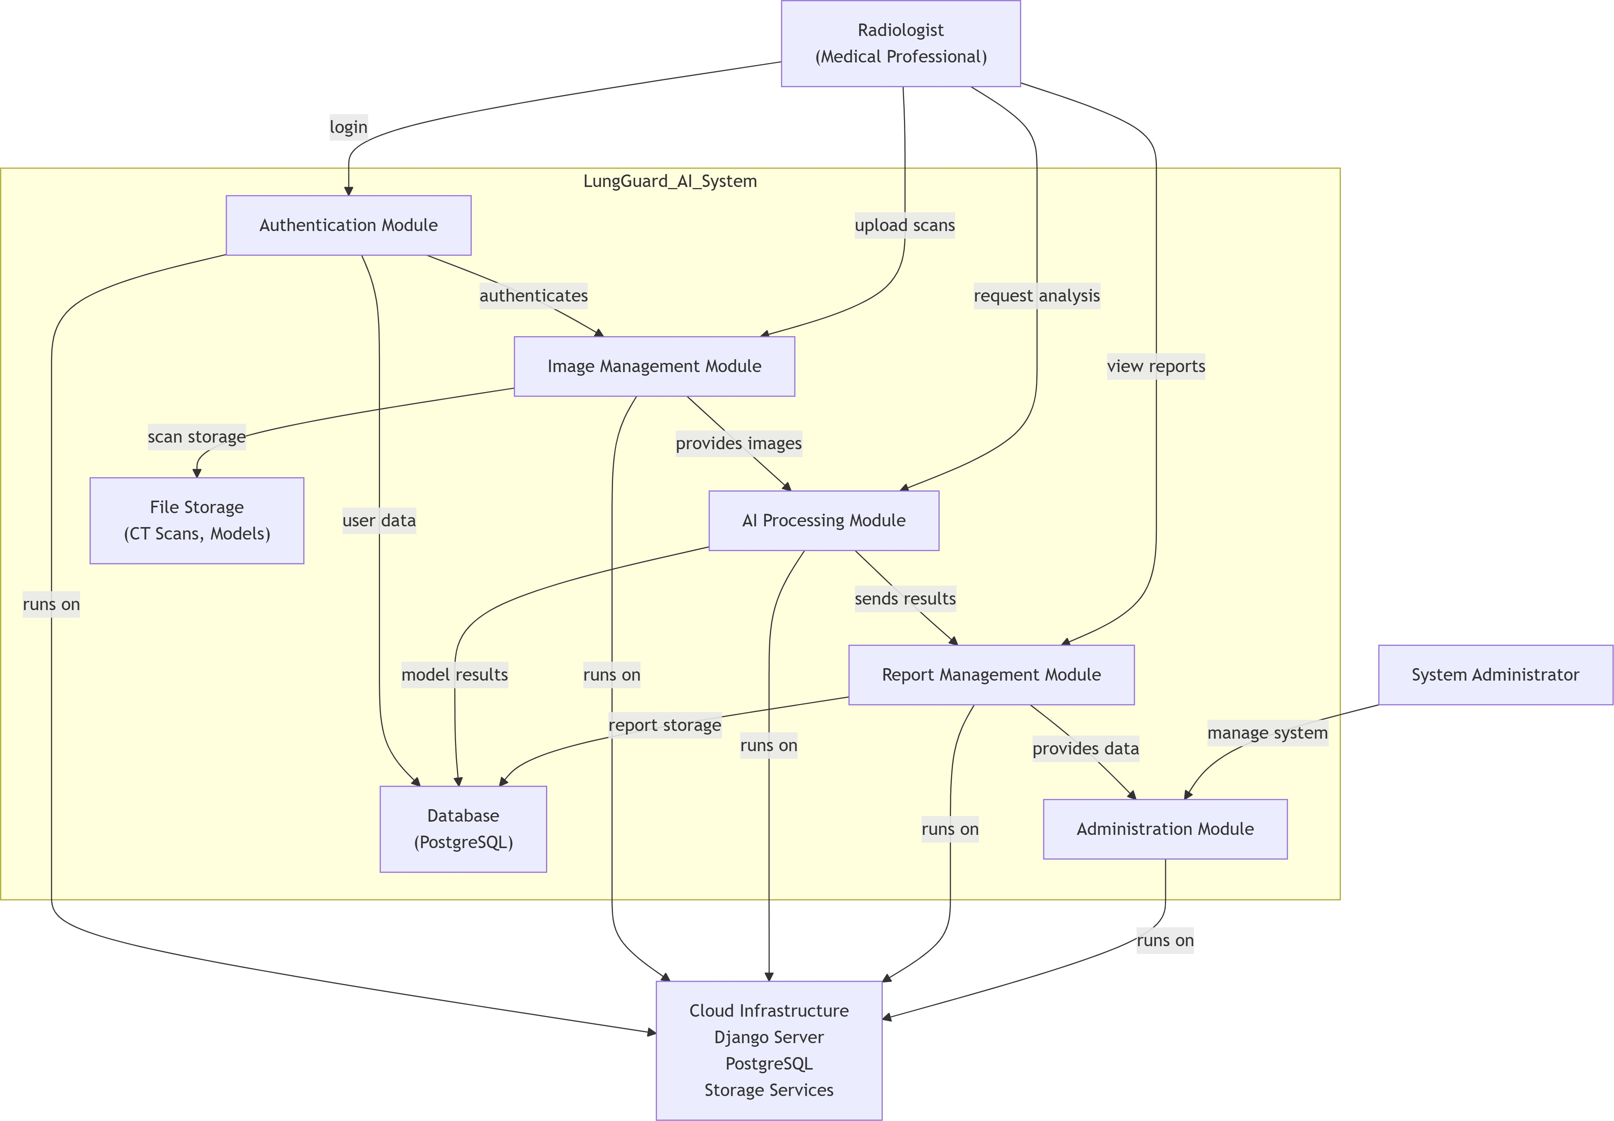
Figure 2: Decomposition diagram
- MVC Pattern: Provides clear separation between data models, business logic, and presentation layers, facilitating independent development and testing.
- Layered Architecture: Ensures modularity where each layer has specific responsibilities, making the system easier to understand, maintain, and scale.
- Modular Decomposition: Allows parallel development of components (authentication, image processing, AI inference) by different team members in an academic setting.

Security and Compliance Considerations:
    - Medical data protection requirements dictate encrypted storage (AES-256) and transmission (TLS 1.3)
    - Audit trail requirements for diagnostic decisions (HIPAA compliance)
    - Model version tracking for clinical validation and reproducibility
    - Data anonymization to protect patient privacy while maintaining clinical utility Alternative architectures considered included micro services approach, but this was rejected due to increased complexity and latency concerns for real-time diagnosis in an academic project timeline. A standalone desktop application was also considered but rejected for deployment and maintenance challenges in clinical environments.

DATA DESIGN

Data Description
The system transforms medical imaging data and diagnostic information into a relational database structure with careful consideration of data privacy, integrity, and clinical workflow efficiency. The design emphasizes normalized tables with proper indexing for clinical query performance while maintaining referential integrity for patient records across multiple CT scans and diagnoses.
Data storage is organized into six logical categories:
- User Management Data: Radiologist authentication credentials (hashed), profiles, permissions, session information, and activity audit logs.
- Patient Management Data: Anonymized patient information, case numbers, demographic data (age, gender), and temporal tracking for longitudinal studies.
- Imaging Data: CT scan metadata including file paths, formats (DICOM/JPEG/PNG), acquisition dates, preprocessing status, quality metrics, and storage references.
- Diagnostic Data: AI inference results including detection classifications (Healthy/Benign/Malignan confidence scores (0.0000-1.0000), cancer types for malignant cases, and processing timestamps.
- Reporting Data: Generated diagnostic reports in HTML/PDF formats, radiologist validation status, clinical notes, and report version history.
- System Management Data: AI model versions, performance metrics, system configurations, backup schedules, and operational logs.

Data Dictionary

Entity/Attribute | Data Type | Description
Radiologist | Entity | Medical professional authorized to use  the system for diagnostic support
radiologist id | INTEGER | Primary key, auto-increment unique  identifier for each radiologist
username | VARCHAR(50) | Unique login identifier, minimum 5  characters, maximum 50
password hash | VARCHAR(255 | )Securely hashed password using  PBKDF2 with SHA-256, 100,000  iterations
license number | VARCHAR(50) | Medical license number for verification  and audit purposes
Patient | Entity | Anonymized patient information for  case management
patient id | INTEGER | Primary key, auto-increment unique  identifier for each patient
case number | VARCHAR(50) | Unique case identifier following hospital numbering system
anonymized id | VARCHAR(100 | )De-identified patient reference using  SHA-256 hash of original ID
CT Scan | Entity | CT scan image metadata and storage  information
scan id | INTEGER | Primary key, auto-increment unique  identifier for each CT scan
file path | VARCHAR(255 | )Encrypted storage location of CT scan  file in cloud storage
file format | VARCHAR(10) | Image format: DICOM (medical standard), JPEG, or PNG
quality score | DECIMAL(5,2) | Image quality assessment score (0.00100.00) from preprocessing
Diagnosis Result | Entity | AI inference results from CT scan analysis
result id | INTEGER | Primary key, auto-increment unique  identifier for each result

Entity/Attribute | Data Type | Description
detection result | VARCHAR(20) | Classification: Healthy (no cancer), Benign, Malignant, or Inconclusive
confidence score | DECIMAL(5,4) | AI model confidence level ranging from  0.0000 (no confidence) to 1.0000 (certain)
cancer type | VARCHAR(50) | Specific cancer type if malignant: Adenocarcinoma, Squamous Cell, etc.
processing time | DECIMAL(10,4 | )Inference time in seconds with millisecond precision
DiagnosisReport | Entity | Comprehensive diagnostic report for  clinical use
report id | INTEGER | Primary key, auto-increment unique  identifier for each report
report content | TEXT | Formatted diagnostic report in HTML  with embedded CSS for PDF generation
validation status | VARCHAR(20) | Radiologist validation: Pending, Con-  firmed, Revised, or Rejected
radiologist notes | TEXT | Additional clinical observations and  recommendations from radiologist
Audit Log | Entity | System activity tracking for compliance  and security
log id | INTEGER | Primary key, auto-increment unique  identifier for each log entry
action type | VARCHAR(50) | Type of action: Login, Upload, Analysis, Report Generation, etc.
ip address | VARCHAR(45) | IP address of user performing action  (supports IPv6)
Model Version | Entity | AI model version tracking for repro Ducibility
version id | INTEGER | Primary key, auto-increment unique  identifier for each model version
model name | VARCHAR(100 | )Name of the CNN model:  lung cancer detector, cancer type classifier
version number | VARCHAR(20) | Semantic version number: major.minor.patch (e.g., 2.1.0)
accuracy metrics | JSON | Performance metrics on validation set:  accuracy, precision, recall, F1-score
deployment date | TIMESTAMP | Date and time when model was deployed to production environment
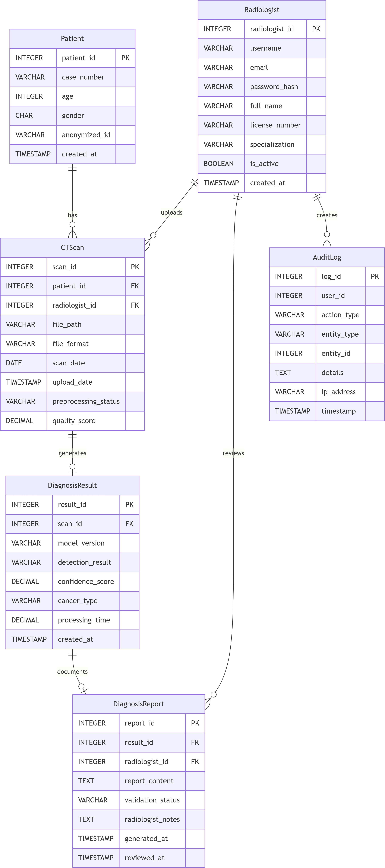

Figure 3: Entity Relationship Diagram (ERD)

COMPONENT DESIGN
The system is implemented using object-oriented design principles with Django models representing business entities, views handling business logic, and templates managing presenation. Each component follows the Single Responsibility Principle and is designed for testability, maintainability, and extensibility to accommodate future enhancements.

HUMAN INTERFACE DESIGN

Overview of User Interface
The user interface is designed with clinical usability as the primary focus, following principles of medical software design that emphasize clarity, efficiency, and error prevention. The interface features three main workflows: (1) authentication and dashboard navigation for radiologists, (2) CT scan upload and processing interface with real-time feedback, and (3) comprehensive report viewing and management system with search, filter, and validation capabilities.
The design employs a clean, professional color scheme using clinical blues and whites with high contrast ratios (minimum 4.5:1) for readability in various lighting conditions. Interactive elements provide clear visual feedback, and critical information (confidence scores, validation status) uses color-coded indicators following medical convention (green=normal, yellow=caution, red=alert). The interface is fully responsive using Bootstrap grid system to accommodate different screen sizes from desktop workstations to tablet devices used in hospital rounds.

Screen Images

Screen Objects and Actions

REQUIREMENTS MATRIX

Req ID | Requirement from SRS | Design Component Handling  Requirement
FR-1 | Radiologist Authentication  System | Authentication Module, Radiologist Class with PBKDF2 hashing, Session Management
FR-2 | CT Scan Upload and Vali dation | Image Management Module,  CTScan Class with format validation, size limits, quality  checking

Req ID | Requirement from SRS | Design Component Handling  Requirement
FR-3 | AI-Powered Cancer Detection | AI Processing Module, Cancer Detection Model Class with CNN inference, confidence scoring
FR-4 | Cancer Type Identification | AI Processing Module (secondary  classifier), Diagnosis Result Class with type classification
FR-5 | Instant Diagnosis Reporting | Report Management Module, Diagnosis Report Class with tem- plate rendering, PDF generation
FR-6 | Report History Management | Report Management Module,  Database design with search indexes, filter implementation
Performance-  1 | CT scan processing within  15 seconds | Optimized preprocessing  pipeline, GPU acceleration for CNN, Caching layer
Performance-  2 | System response under 3  seconds | Database query optimization,  Frontend lazy loading, AJAX for partial updates
Reliability-  1 | 99% system uptime | Cloud deployment with auto-  scaling, Database replication, Health monitoring system
Security-1 | Secure password hashing | Authentication Module using  PBKDF2 with SHA-256, 100,000  iterations
Security-2 | HTTPS encryption for all  transmissions | Web server configuration with  TLS 1.3, HSTS headers, SSL certificate management
Security-3 | Medical data protection  compliance | Data encryption at rest (AES-  256), Access control lists, Audit logging system
Availability-  1 | 24/7 system accessibility | Load-balanced deployment,  Scheduled maintenance windows, Disaster recovery plan
Maintainability-1 | Modular code structure | Component-based architecture,  Clear interfaces, Comprehensive documentation
Portability-1 | Cross-browser compatibility | Responsive web design using  Bootstrap, Progressive enhancement, Browser testing suite

Req ID | Requirement from SRS | Design Component Handling  Requirement
Compliance-  1 | Medical software regulatory  standards | HIPAA compliance module, Audit trail system, Data retention policies
Compliance-  2 | Data protection regulations | GDPR compliance features, Data  anonymization, Right to erasure implementation
Usability-1 | Intuitive clinical interface | User-centered design, Clinical  workflow optimization, Accessibility compliance (WCAG 2.1)

APPENDICES

Unit Testing:
    - Framework: Django Test Framework with pytest
    - Coverage Target: 85% for core business logic, 70% overall

Test Categories:
- Model tests: Database operations, validation logic, relationships
- View tests: Request handling, authentication, permission checks
- Form tests: Data validation, cleaning, file upload handling
- Utility tests: Image processing algorithms, report generation logic
- Mocking Strategy: Mock external dependencies (file system, AI models, cloud services)
- Test Data: Fixtures for medical imaging scenarios, edge cases

Integration Testing:

End-to-End Workflow Testing:
- Complete flow: Login → Upload CT scan → AI analysis → Report generation →Validation
- Concurrent user scenarios: Multiple radiologists uploading simultaneously
- Large file handling: Upload and process 500MB DICOM files

Database Integration Tests:
  - Transaction rollback testing for failed operations
  - Referential integrity testing with cascade deletes Performance testing with large datasets (10,000+ records)

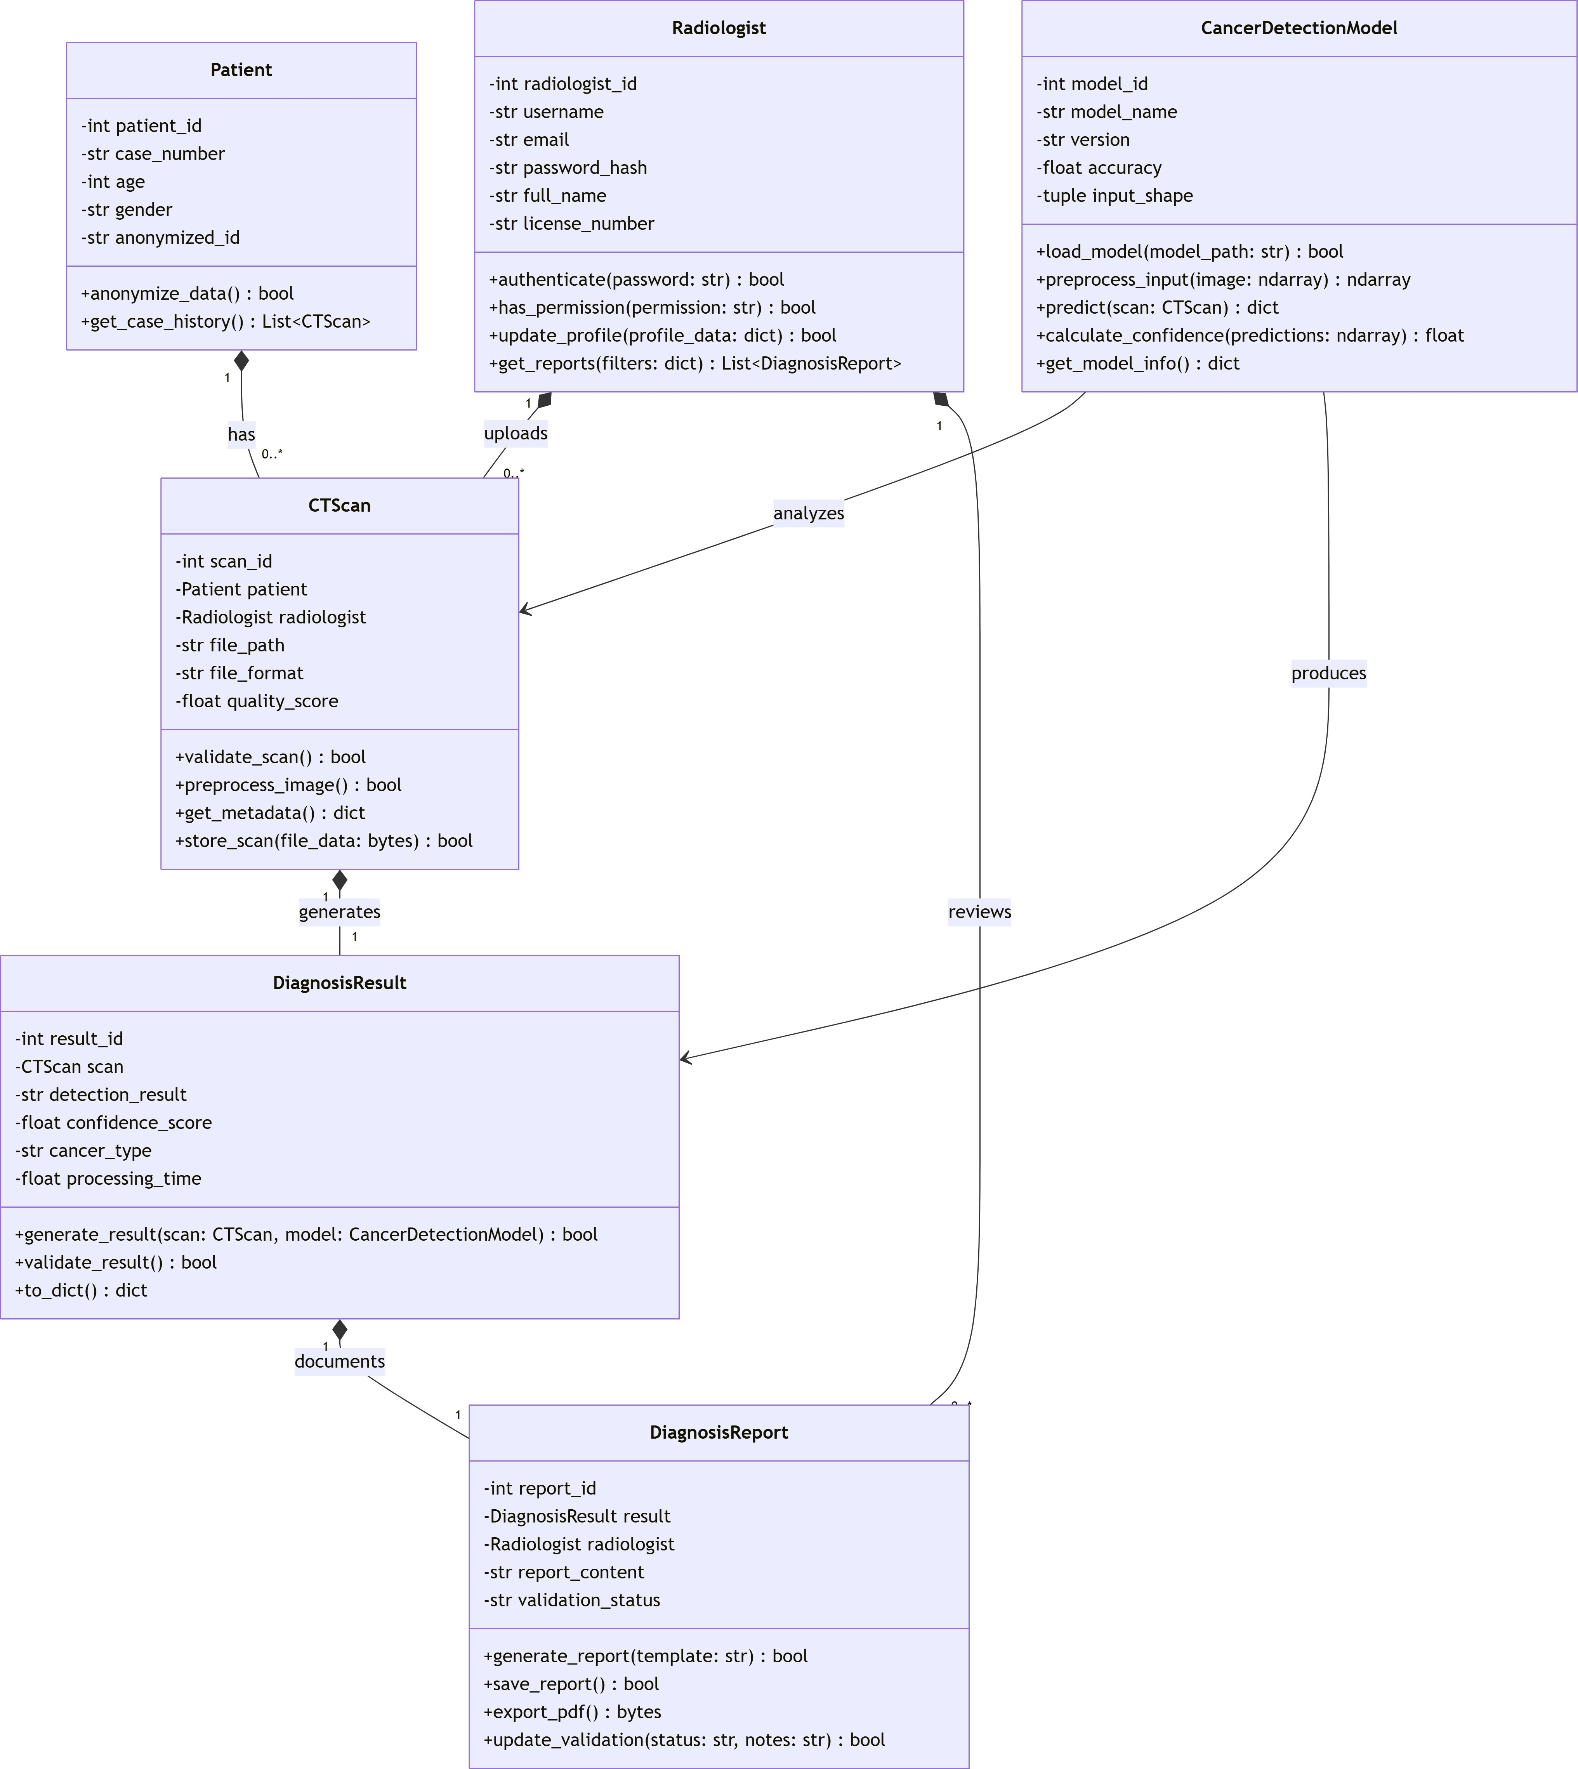
Figure 4: Class Diagram for Core Components

File System Integration:
  - Upload/download integrity verification
  - Storage quota enforcement testing
  - Concurrent file access testing

API Integration Testing:
Verify all REST endpoints with actual HTTP requests

Performance Testing:

Load Testing:
  - Simulate 50 concurrent radiologists performing typical workflows
  - Measure response times under load (p95, p99 percentiles)
  - Identify bottlenecks in database queries, file I/O, AI inference

Stress Testing:
  - Push system beyond normal operational limits
  - Test with 100+ concurrent uploads
  - Verify graceful degradation and recovery

CT Scan Processing Benchmarks:
  - Measure processing time for different image sizes and formats
  - Optimize preprocessing pipeline based on benchmarks
  - Verify 15-second processing time requirement under load

Medical Validation Testing:

AI Model Accuracy Validation:
  - Test on holdout dataset from IQ-OTH/NCCD
  - Measure accuracy, precision, recall, F1-score
  - Compare with baseline (radiologist performance)

Clinical Workflow Usability Testing:
  - Conduct usability studies with actual radiologists
  - Measure time to complete diagnostic tasks
  - Collect feedback on interface design and workflow efficiency

Report Accuracy Testing:
  - Verify report content matches analysis results
  - Test PDF generation with medical formatting standards
  - Validate inclusion of required disclaimers and warnings

Compliance Testing:

HIPAA Compliance Testing:
  - Verify audit trail completeness
  - Test data access controls and logging
  - Validate data retention and deletion policies

Accessibility Testing:
  - WCAG 2.1 Level AA compliance testing
  - Screen reader compatibility testing
  - Keyboard navigation testing

Browser Compatibility Testing:
  - Test on Chrome, Firefox, Safari, Edge (latest versions)
  - Mobile device testing (tablet interface)
  - Different screen resolution testing

9 .Reference Material
- IEEE Standard 1016-2009 - Recommended Practice for Software Design Descriptions
- PulseLungs Software Requirements Specification (SRS) Document
- Django 4.x Documentation
- TensorFlow/PyTorch Documentation
- IQ-OTH/NCCD Lung Cancer Dataset Documentation
- DICOM Standard (Digital Imaging and Communications in Medicine)
- Medical Software Regulatory Standards (HIPAA, GDPR for medical data)
- UML 2.5 Specification

